close all

clear

clc

r_max=100;

theta_E=-5;

theta_I=0;

alpha_E=0.05;

alpha_I=1;

W_EE=2;

W_EI=2.5;

W_IE=-2.5;

W_II=-2;

t_max=3;

r_E(1)=50;

r_I(1)=50;

dt=0.1e-3;

t=0:dt:t_max;

Istim = zeros(size(t));

ind = find (t > 1 & t < 2);

Istim(ind) = 20;

Ibase_E = 0;

Ibase_I = 0;

tau_E=5e-3;

tau_I=5e-3;

Iapp_E = ones(size(t))*Ibase_E;

Iapp_I = ones(size(t))*Ibase_I+Istim;

r2null = ones(size(t))

for n = 2:length(t)

I_E(n)=W_EE*r_E(n-1)+W_IE*r_I(n-1)+Iapp_E(n-1);

I_I(n)=W_EI*r_E(n-1)+W_II*r_I(n-1)+Iapp_I(n-1);

r_E_temp(n) = r_E(n-1)+(dt/tau_E)*(-r_E(n-1)+alpha_E*((I_E(n)-theta_E)^2).*sign(I_E(n)-theta_E));

r_I_temp(n) = r_I(n-1)+(dt/tau_I)*(-r_I(n-1)+alpha_I*((I_I(n)-theta_I)));

r_E(n) = min(max(r_E_temp(n), 0), r_max);

r_I(n) = min(max(r_I_temp(n), 0), r_max);

%r2null(n) = (1/tau_E)*(-r_E(n-1)+alpha_E*((I_E(n)-theta_E)^2).*sign(I_E(n)-theta_E));

end

% allowed_vals = find((r_E >= 0 ).*( r_E <= r_max ));

% allowed_vals1 = find((r_I>= 0 ).*( r_I <= r_max ));

f1=figure(1);

% subplot(3,1,1);

% plot(t,r_E);

% xlabel('t (sec)')

% ylabel('r_{E} (Hz)')

% grid on

% hold on

% plot(t,r_I);

%

% xlabel('t (sec)')

% ylabel('r_{I} (Hz)')

% plot(t(allowed_vals),r_E(allowed_vals));

subplot(1,2,1)

plot(t,r_E);

xlabel('t (sec)')

ylabel('r (Hz)')

grid on

hold on

%plot(t(allowed_vals1),r_I(allowed_vals1));

plot(t,r_I);

xlabel('t (sec)')

ylabel('r (Hz)')

legend('r_{E}','r_{I}')

grid on

subplot(1,2,2)

plot(r_I,r_E)

ylabel('r_{E}')

xlabel('r_{I}')

% allowed_vals2 = find((r2null > 0 ).*( r2null < r_max ));

% figure(2)

% plot(r_E(allowed_vals2),r2null(allowed_vals2),'k');

% subplot(3,1,3);

% r_E1=1:length(r_I(allowed_vals1))

% plot(t(allowed_vals1),r_I(allowed_vals1))

% hold on

% r_I1=1:length(r_I(allowed_vals))

% plot(r_E(allowed_vals),t(allowed_vals))

% axis([0 t_max 0 r_max])

% xlabel('r_{E} (sec)')

% ylabel('r_{I} (Hz)')

grid on

suptitle('part 1');

saveas(f1, sprintf('1.png'));

%% part2

r_max=100;

theta_E=-5;

theta_I=0;

alpha_E=0.05;

alpha_I=1;

W_EE=2;

W_EI=2.5;

W_IE=-2.5;

W_II=-2;

t_max=3;

r_E(1)=50;

r_I(1)=50;

dt=0.1e-3;

t=0:dt:t_max;

Istim = zeros(size(t));

ind = find (t > 1 & t < 2);

Istim(ind) = 20;

Ibase_E = 25;

Ibase_I = 15;

tau_E=5e-3;

tau_I=5e-3;

Iapp_E = ones(size(t))*Ibase_E;

Iapp_I = ones(size(t))*Ibase_I+Istim;

for n = 2:length(t)

I_E(n)=W_EE*r_E(n-1)+W_IE*r_I(n-1)+Iapp_E(n-1);

I_I(n)=W_EI*r_E(n-1)+W_II*r_I(n-1)+Iapp_I(n-1);

r_E_temp(n) = r_E(n-1)+(dt/tau_E)*(-r_E(n-1)+alpha_E*((I_E(n)-theta_E)^2).*sign(I_E(n)-theta_E));

r_I_temp(n) = r_I(n-1)+(dt/tau_I)*(-r_I(n-1)+alpha_I*((I_I(n)-theta_I)));

r_E(n) = min(max(r_E_temp(n), 0), r_max);

r_I(n) = min(max(r_I_temp(n), 0), r_max);

end

allowed_vals = find((r_E >= 0 ).*( r_E <= r_max ));

allowed_vals1 = find((r_I>= 0 ).*( r_I <= r_max ));

f2=figure(2);

subplot(1,2,1)

plot(t,r_E);

xlabel('t (sec)')

ylabel('r (Hz)')

grid on

hold on

%plot(t(allowed_vals1),r_I(allowed_vals1));

plot(t,r_I);

xlabel('t (sec)')

ylabel('r (Hz)')

legend('r_{E}','r_{I}')

grid on

subplot(1,2,2)

plot(r_I,r_E)

ylabel('r_{E}')

xlabel('r_{I}')

% subplot(3,1,3);

% r_E1=1:length(r_I(allowed_vals1))

% plot(t(allowed_vals1),r_I(allowed_vals1))

% hold on

% r_I1=1:length(r_I(allowed_vals))

% plot(r_E(allowed_vals),t(allowed_vals))

% axis([0 t_max 0 r_max])

% xlabel('r_{E} (sec)')

% ylabel('r_{I} (Hz)')

grid on

title('part 2');

%legend('r_{E}','r_{I}')

saveas(f2, sprintf('2.png'));

%% part 3

r_max=100;

theta_E=-5;

theta_I=0;

alpha_E=0.05;

alpha_I=1;

W_EE=2;

W_EI=2.5;

W_IE=-2.5;

W_II=-2;

t_max=3;

r_E(1)=50;

r_I(1)=50;

dt=0.1e-3;

t=0:dt:t_max;

Istim = zeros(size(t));

ind = find (t > 1 & t < 2);

Istim(ind) = 20;

Ibase_E = 0;

Ibase_I = 0;

tau_E=2e-3;

tau_I=10e-3;

Iapp_E = ones(size(t))*Ibase_E;

Iapp_I = ones(size(t))*Ibase_I+Istim;

for n = 2:length(t)

I_E(n)=W_EE*r_E(n-1)+W_IE*r_I(n-1)+Iapp_E(n-1);

I_I(n)=W_EI*r_E(n-1)+W_II*r_I(n-1)+Iapp_I(n-1);

r_E_temp(n) = r_E(n-1)+(dt/tau_E)*(-r_E(n-1)+alpha_E*((I_E(n)-theta_E)^2).*sign(I_E(n)-theta_E));

r_I_temp(n) = r_I(n-1)+(dt/tau_I)*(-r_I(n-1)+alpha_I*((I_I(n)-theta_I)));

r_E(n) = min(max(r_E_temp(n), 0), r_max);

r_I(n) = min(max(r_I_temp(n), 0), r_max);

end

allowed_vals = find((r_E >= 0 ).*( r_E <= r_max ));

allowed_vals1 = find((r_I>= 0 ).*( r_I <= r_max ));

f3=figure(3);

subplot(1,2,1)

plot(t,r_E);

xlabel('t (sec)')

ylabel('r (Hz)')

grid on

hold on

%plot(t(allowed_vals1),r_I(allowed_vals1));

plot(t,r_I);

xlabel('t (sec)')

ylabel('r (Hz)')

legend('r_{E}','r_{I}')

grid on

subplot(1,2,2)

plot(r_I,r_E)

ylabel('r_{E}')

xlabel('r_{I}')

% subplot(3,1,3);

% r_E1=1:length(r_I(allowed_vals1))

% plot(t(allowed_vals1),r_I(allowed_vals1))

% hold on

% r_I1=1:length(r_I(allowed_vals))

% plot(r_E(allowed_vals),t(allowed_vals))

% axis([0 t_max 0 r_max])

% xlabel('r_{E} (sec)')

% ylabel('r_{I} (Hz)')

grid on

title('part 3');

%legend('r_{E}','r_{I}')

saveas(f3, sprintf('3.png'));

%% part 4

r_max=100;

theta_E=-5;

theta_I=0;

alpha_E=0.05;

alpha_I=1;

W_EE=2;

W_EI=2.5;

W_IE=-2.5;

W_II=-2;

t_max=3;

r_E(1)=50;

r_I(1)=50;

dt=0.1e-3;

t=0:dt:t_max;

Istim = zeros(size(t));

ind = find (t > 1 & t < 2);

Istim(ind) = 20;

Ibase_E = 25;

Ibase_I = 15;

tau_E=2e-3;

tau_I=10e-3;

Iapp_E = ones(size(t))*Ibase_E;

Iapp_I = ones(size(t))*Ibase_I+Istim;

for n = 2:length(t)

I_E(n)=W_EE*r_E(n-1)+W_IE*r_I(n-1)+Iapp_E(n-1);

I_I(n)=W_EI*r_E(n-1)+W_II*r_I(n-1)+Iapp_I(n-1);

r_E_temp(n) = r_E(n-1)+(dt/tau_E)*(-r_E(n-1)+alpha_E*((I_E(n)-theta_E)^2).*sign(I_E(n)-theta_E));

r_I_temp(n) = r_I(n-1)+(dt/tau_I)*(-r_I(n-1)+alpha_I*((I_I(n)-theta_I)));

r_E(n) = min(max(r_E_temp(n), 0), r_max);

r_I(n) = min(max(r_I_temp(n), 0), r_max);

end

allowed_vals = find((r_E >= 0 ).*( r_E <= r_max ));

allowed_vals1 = find((r_I>= 0 ).*( r_I <= r_max ));

f4=figure(4);

subplot(1,2,1)

plot(t,r_E);

xlabel('t (sec)')

ylabel('r (Hz)')

grid on

hold on

%plot(t(allowed_vals1),r_I(allowed_vals1));

plot(t,r_I);

xlabel('t (sec)')

ylabel('r (Hz)')

legend('r_{E}','r_{I}')

grid on

subplot(1,2,2)

plot(r_I,r_E)

ylabel('r_{E}')

xlabel('r_{I}')

% subplot(3,1,3);

% plot(t(allowed_vals),r_E(allowed_vals));

% hold on

% plot(t(allowed_vals1),r_I(allowed_vals1));

grid on

title('part 4');

%legend('r_{E}','r_{I}')

saveas(f4, sprintf('4.png'));

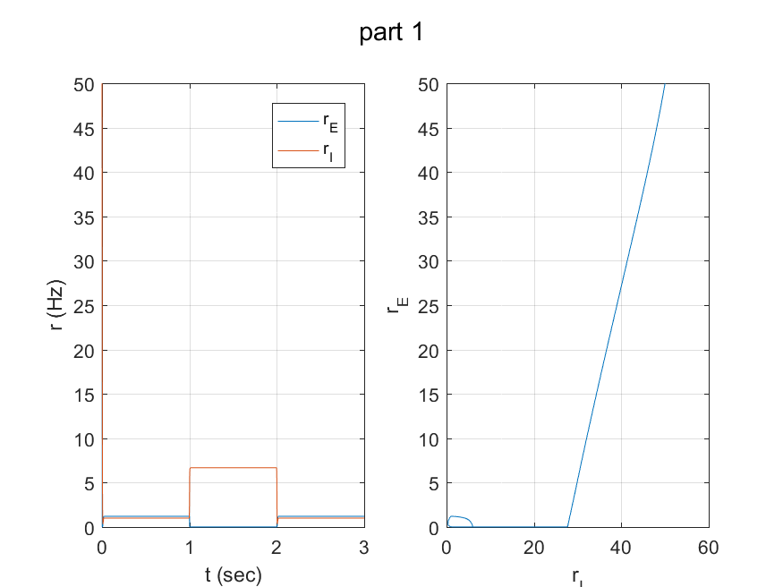

I can see system is stable because effective excitatory feedback is relatively weak . I also can see that increasing inhibitory input cause excitory rate to be zero and when we remove the extra current it once again back to stablity

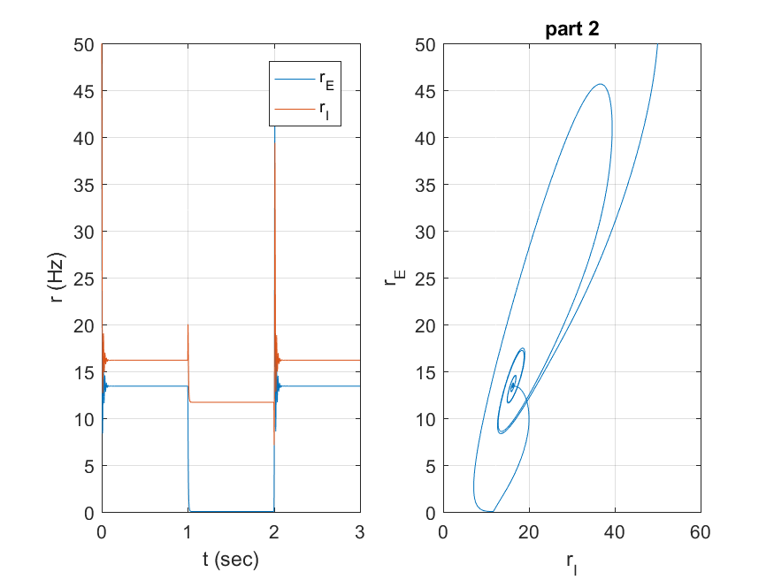

Here I can see increasing the base line keeps the system still stable but I can see some oscilations before reaching to stability

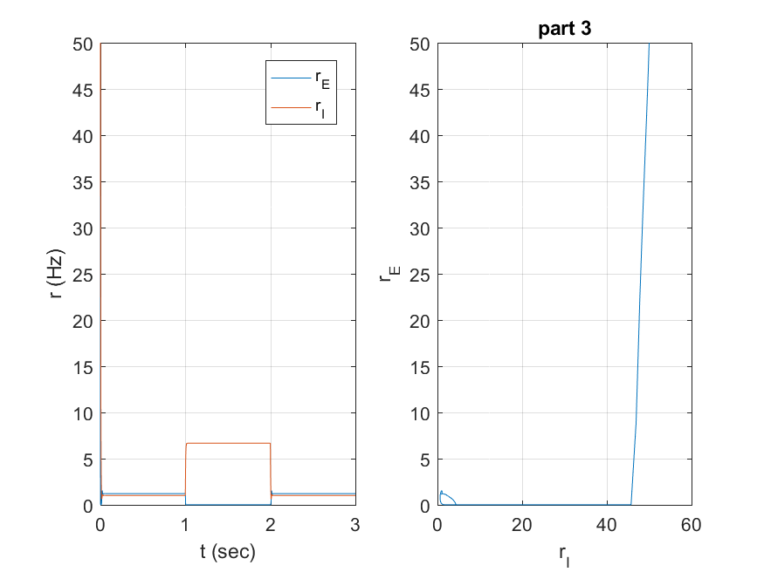

I can see changing a higher tau_I results in the inhibitory unit's response to changes in its input current being slower. This means the inhibitory influence on the excitatory unit will also be slower to rise and fall. decreasing tau_E causes faster excitation.

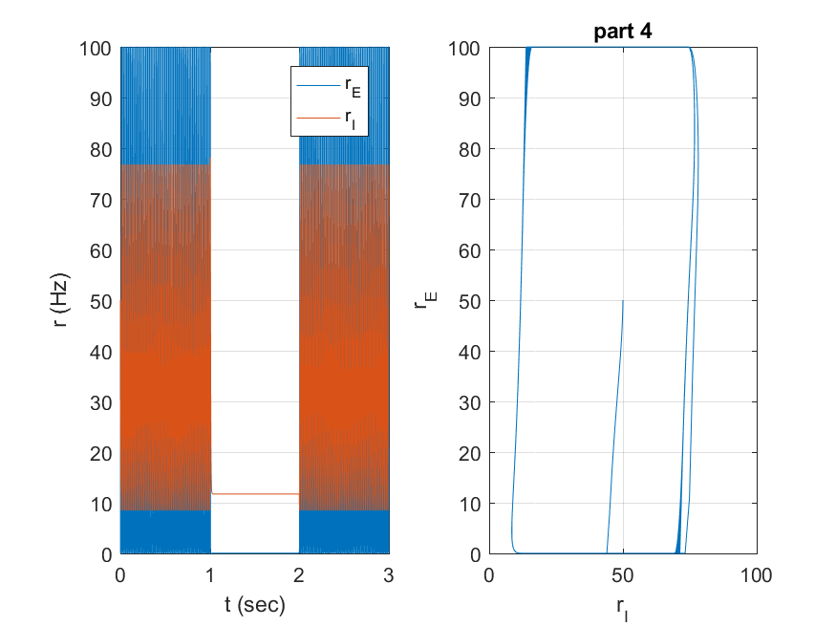

I can see the increase of tau along with change in base lines makes the system unstable and increase the firing rate in comparison with part 2